 | Autumn | Spring | Summer | Additional units
Units: | 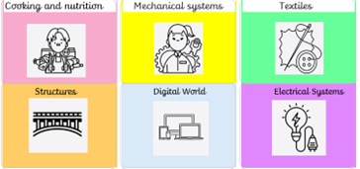  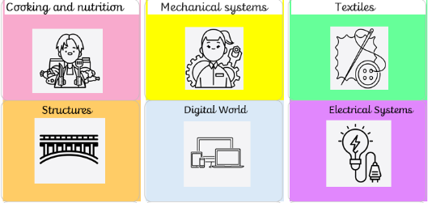  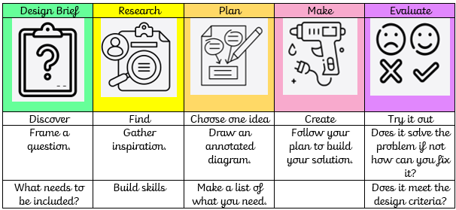
EYFS | Structures: Junk modelling  Cooking and nutrition: Soup | Textiles: Bookmarks  Structures: Boats | Seasonal projects  A series of seasonal projects to choose from to deliver across the year – covering Autumn, Christmas, Easter, Spring and Summer
YEAR 1 | Textiles:  Puppets  (4 lessons) Explore methods of joining fabric. Design and make a character-based hand puppet using a preferred joining technique, before decorating.  Example theme: Storybook character. Alternative theme: Easter animals | Structures  Constructing  windmills  (4 lessons) | Cooking and nutrition  Make a fruit yoghurt pot | Mechanisms: Making a moving story book (Stand alone)  Explore slider mechanisms and the movement they output, to design, make and evaluate a moving storybook from a range of templates.
YEAR 2 | Mechanical systems –  Making a moving monster (4 lessons) Explore levers, linkages and pivots through existing products and experimentation, use this research to construct and assemble a moving monster.  Example theme: Moving monster. Alternative theme: Easter – Mechanical animals | Cooking and nutrition  Prepare to party- Make a party dish | Structures  Baby bear's chair (4 lessons)Explore stability and methods to strengthen structures, to understand Baby Bear’s chair weaknesses and develop an improved solution for him to use. | Textiles: Pouches  Learn how to sew a running stitch ready to design, make and decorate a pouch using a template.
YEAR 3 | Textiles: Cross-stitch and appliqué  Learn and apply two new sewing techniques – cross-stitch and appliqué. Utilise these new skills to design and make a cushion or Egyptian collar. (4 lessons) | Structures  Constructing a castle  Identify and learn about the key features of a castle, before designing and making a recycled-material castle  (4 lessons) | Cooking and nutrition  Be a Baker  Make some bread. | Digital World  Electronic charm (4 lessons):  Designing, coding, making and promoting a Micro:bit electronic charm to use in low-light conditions. Children develop their understanding of programming to monitor and control their products.
YEAR 4 | Cooking and nutrition  Lovely Lunch  Make a sandwich for a family member | Digital World  An alternative to the original mindful moments’ timer unit, including a greater focus on evaluation, use of the virtual micro: bit and new video content. | Mechanical systems: Making a slingshot car.  Transforming lollipop sticks, wheels, dowels and straws into a moving car. Using a glue gun to, making a launch mechanism, designing and making the body of the vehicle using nets and assembling these to the chassis. 4 lessons | Electrical systems: Torches Applying their scientific understanding of electrical circuits, children create a torch, designing and evaluating their product against set design criteria.
YEAR 5 | Textiles:  Stuffed toys  Design a stuffed toy and make decisions on materials, decorations and attachments (appendages), after learning how to sew a blanket stitch.  Lessons: 4 | Cooking and nutrition  Food Technology  Serve a Salad  Make a salad for a busy teacher. | Mechanical systems  Making a pop-up book  Creating a four-page pop-up storybook design incorporating a range of mechanisms and  decorative features, including: structures, levers, sliders, layers and spacers.  Lessons: 4 | Digital world: Monitoring devices  Apply Computing knowledge and understanding to program a Micro: bit animal monitoring device. Develop 3D CAD skills by learning how to navigate the Tinkercad interface and essential tools to combine multiple objects.  Lessons: 4
YEAR 6 | Structures  Research existing playground equipment and their different forms, before designing and developing a range of apparatus to meet a list of specified design criteria.  Lessons: 4 | Cooking and nutrition  Grab and Go  Make an all in one hand held meal. | Electrical systems:  Steady hand game  Understand what is meant by fit for purpose design and form follows function. Design and develop a steady hand game using a series circuit, including housing and backboard

