 | Autumn 1  (8 weeks) |  | Autumn 2  (7 weeks)
Theme: | Harvest | Halloween | BHM | Memorial Day | Winter Wonderland
Writing Genre: | - Short burst writing  - Descriptive writing: settings & characters  - Autumn Experience: Recount | - Narratives  - Descriptive writing: settings & characters | - Diary entries | - Poetry | - Letters  - Instructions
EYFS | 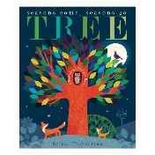  Tree: Seasons come,  Seasons go by Britta Teckentrup | 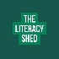  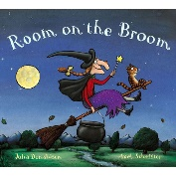  Room on the Broom by Julia Donaldson | 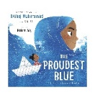  The Proudest Blue by Ibtihaj Muhammad | Armistice Poetry:  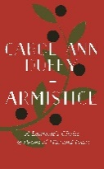  Whole school to be absorbed in a ‘memorial day’ poem and recite in end of day assembly. Children to produce a piece of art to coincide with poem | 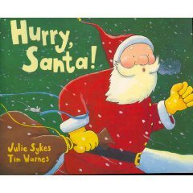  Hurry Santa by Julia Sykes
YEAR 1 | 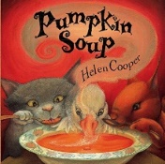  Pumpkin Soup by Helen Cooper | 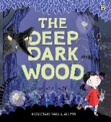  The Deep Dark Wood by Algy Craig Hall | 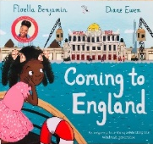  Coming to England by Floella Benjamin |  | 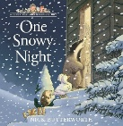  One Snowy Night by Nick Butterworth
YEAR 2 | 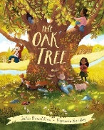  The Oak Tree by Julia Donaldson | 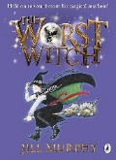  The Worst Witch by Jill Murphy | 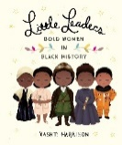  Little Leaders by Vashti Harrison |  | 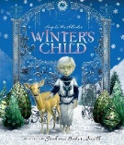  Winter’s Child by Angela Mcallister
YEAR 3 | 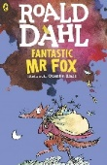  Fantastic Mr Fox by Roald Dahl | 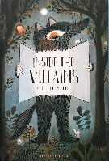  Inside the Villains by Clotilde Perrin | 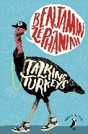  Talking Turkeys by Benjamin Zephaniah |  | 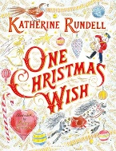  One Christmas Wish by Katherine Rundell
YEAR 4 | 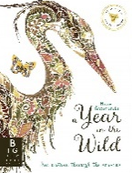  A Year in the Wild by Helen Ahpornsiri | 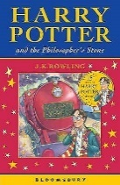  Harry Potter & the Philosopher’s Stone by J.K.Rowling | 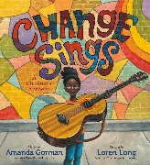  Change Sings by Amanda Gorman |  | 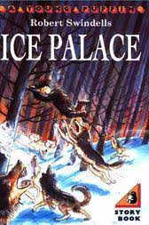  Ice Palace by Robert Swindells
YEAR 5 | 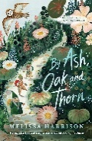  Ash, Oak & Thorn by Melissa Harrison | 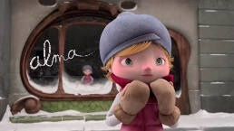  Alma | 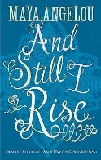  And Still I Rise by Maya Angelou |  | 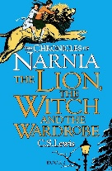  The Lion, the Witch & the Wardrobe by C.S.Lewis
YEAR 6 | 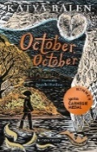  October, October by Katya Balen | 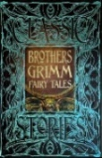  Grimm Tales | 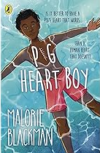  Pig Heart Boy by Malorie Blackman |  | 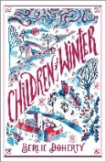  Children of Winter by Berlie Doherty

