 | Spring 1  (6 weeks) | Spring 2  (6 weeks)
Theme: | Mythical Creatures | Midnight Feasts: Poetry
Writing Genre: | - Newspaper report  - Fact files  - Fables  - Descriptive writing  - Hook lesson (7th January) | - Poetry/ oracy/ drama
EYFS | 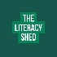  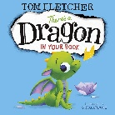  There’s a Dragon in Your book by Tom Fletcher | 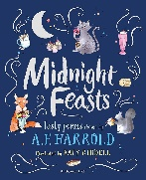  Whole school poetry unit based on Midnight Feasts: Tasty Poems chosen by A.F.Harrold. Focus on performance poetry, oracy skills and drama.
YEAR 1 | 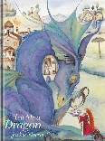  Tell Me a Dragon by Jackie Morris
YEAR 2 | 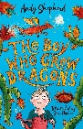  The Boy Who Grew Dragons by Andy Shepherd
YEAR 3 | 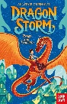  Dragon Storm by Alastair Chisholm
YEAR 4 | 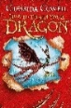  How To Train Your Dragon by Cressida Cowell
YEAR 5 | 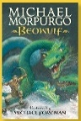  Beowulf by Michael Morpurgo
YEAR 6 | 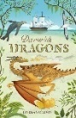  Darwin’s Dragons by Lindsay Galvin

