 | Summer 1  (5 weeks) | Summer 2  (7 weeks)
Theme: | Travel | Botanical World
Writing Genre: | - Posters  - Leaflets  - Newspaper articles  - Reviews  - Recount  - Persuasive writing  - Whole school showcase writing | - Hook lesson (2nd June): letter/picture  - Non-chronological reports  - Letters  - Diaries  - Narratives
EYFS | 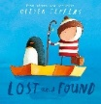  Lost & Found by Oliver Jeffers  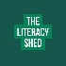 | 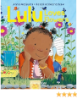  LuLu Loves Flowers Anna McQuinn &  Rosalind Beardshaw
YEAR 1 | 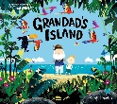  Grandad’s Island by Benji Davis | 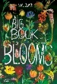  The Big Book of Blooms by Yuval  Zommer
YEAR 2 | 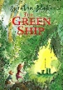  The Green Ship by Quentin Blake | 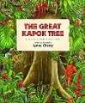  The Great Kapok Tree by Lynne  Cherry
YEAR 3 | 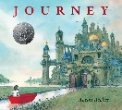  Journey by Aaron Becker | 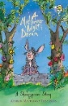  A Midsummer Night’s Dream
YEAR 4 | 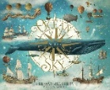  Ocean Meets Sky by Eric & Terry Fan | 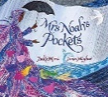  Mrs Noah’s Pockets by Jackie Morries
YEAR 5 | 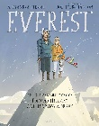  Everest by Alexandra Stewart | 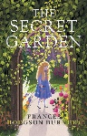  The Secret Garden by Frances Hodgson  Burnett
YEAR 6 | 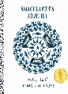  Shackleton’s Journey | 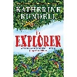  The Explorer by Katherine Rundell

