


Our reception class uniform
Welcome to Henham and Ugley Primary and Nursery School. Please find detailed below our uniform requirements. We encourage a smart appearance and pride in how we represent our school.

We are trying to ensure our play spaces are providing children with the opportunity to get lost in their own imagination. Children's imagination has no rules or boundaries, no right or wrong way to play, act or behave. In a child’s mind, they can be whoever they want to be, resources can be anything their heart desires and their creativity skills are given the freedom to expand and develop to new heights beyond their academic years.
Clothes can be washed; education and memories last a lifetime.

With this in mind, we have two school uniform options.

Option 1 - Traditional School Uniform
Boys | Girls
Grey Trousers (shorts in summer)  White logo or non-logo polo t-shirt.  Navy logo or non-logo sweatshirt.  Black school shoes.  Plain black/grey socks. | Grey skirt/pinafore dress  Blue gingham dress (summer).  White logo or non-logo polo t-shirt.  Navy logo or non-logo sweatshirt/cardigan.  Black shoes.  White/Grey/Navy socks or tights.

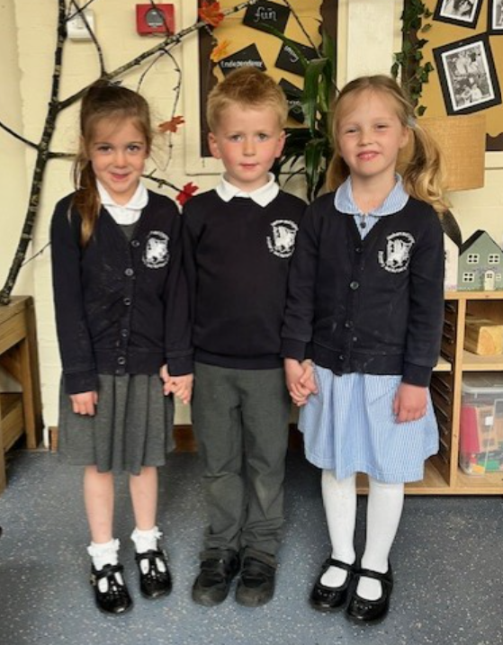

Logo itemed uniform can be purchased following this link:

www.myClothing.com

Option 2 – The ‘curiosity friendly’ uniform
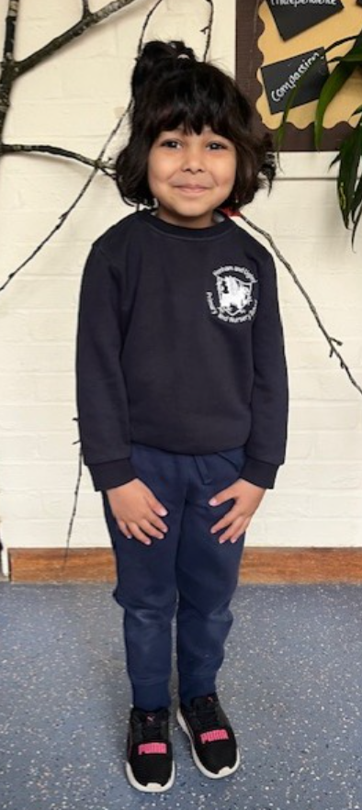
This is a logo or non-logo navy sweatshirt.
Navy non-branded jogging bottoms and a navy blue t-shirt.
Black/navy blue non-branded trainers. There are many options available through Asda, Tesco’s, Clarks etc… Please ensure these are Velcro fastening rather than slip on or laces.

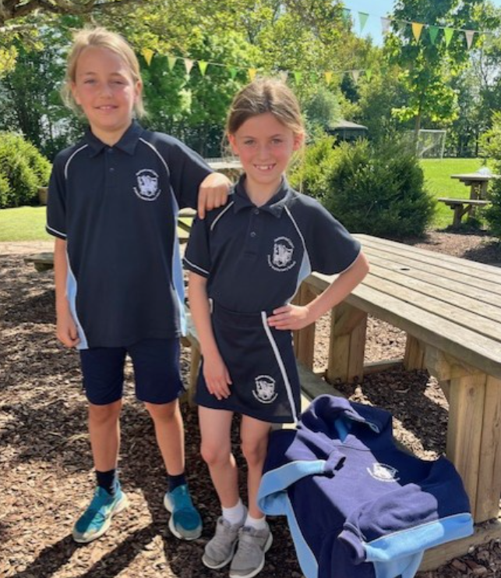
PE uniform
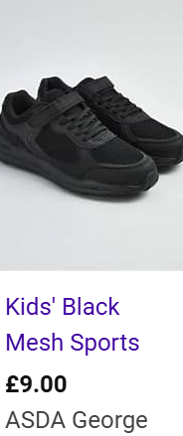

The compulsory PE kit comprises of:
Navy blue logo cycling shorts or skort.
Logo polo t-shirt or t-shirt.
Logo or non-logo navy blue hoody.
Ideally black/navy blue non-branded trainers. There are many options available through Asda, Tesco’s, Clarks etc… Velcro fastening rather than slip on or laces.

PE kits can be ordered through Andrew Hyde using the following link:

https://ahyde.co.uk/collections/henham-and-ugley-primary-and-nursery-school

Puddle Suits
We love to enjoy all weathers and get outside as much as possible. We therefore ask that children have a puddle suit/salopettes and a pair of wellington boots that stay in school.
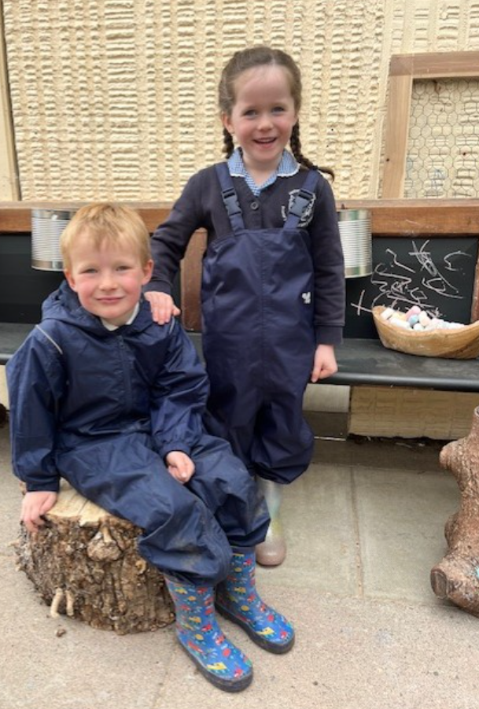

Shoes
Could we please ask that school shoes (which should be worn with our option 1 – tradition uniform) should be black either Velcro. Please try to refrain from buckles and laces.


