

Behaviour Policy

Date of Policy | September 2025
Review Date | September 2026
Author | Nicky Brogan
Updates added

Contents:
Statement of Intent
1. School Values and School Ethos
2. A Relational Behaviour Model
3. General Expectations
4. What do we do to teach and promote positive managements of behaviour?
5. Viewing behaviour as a learning process
6. Our general responses to mistakes and incidents
7. Consequences
8. Henham’s Reflective Road
9. How we support children with additional SEMH needs
10. Our Principles - the things we will do as adults
11. Responsibilities
12. Harm from dysregulated behaviour
13. Risk Assessment Process
14. Physical intervention (control and restraint)- the use of reasonable force
15. Screening and searching pupils
16. Further Guidance
Appendix I – Reflection Road Documents
Appendix II – Our School Rules

Statement of Intent
At Henham and Ugley Primary and Nursery School, we are committed to creating a safe, caring, and inclusive environment where every child feels valued, respected, and able to learn. Our Behaviour Policy is built on strong relationships, mutual trust, and respect for all members of our school community. We believe that positive behaviour is best achieved through understanding, support, and clear expectations, rather than through punishment alone.
We recognise that all children are unique and may sometimes need extra help to manage their feelings and actions. Our approach is to view behaviour as a learning process, supporting children to reflect on their choices and understand the impact of their actions on others. We use restorative practices to help children repair relationships and learn from mistakes, always prioritising their wellbeing and safety.
Staff at our school model kindness, fairness, and consistency, and work closely with families to support every child’s needs. We celebrate positive behaviour and achievements, and we have clear routines and rules to help everyone feel secure. When challenges arise, we respond with understanding and appropriate support, ensuring that all children have the opportunity to thrive both academically and personally.
Our aim is to prepare children to become confident, respectful, and compassionate members of the wider community, equipped with the skills to make positive choices throughout their lives.

1. School Values and School Ethos
School Values
At Henham and Ugley Primary and Nursery school we believe in the importance of relationships, ensuring children feel valued, safe and secure, providing a sense of connection with a member of staff and a belonging to the whole school community. We believe that in order to learn successfully all children need to feel happy and heard.
School Ethos
It is a core aim of our school that every member of the school community feels valued and respected, and that each person is treated fairly and well. We are a caring community, whose values are built on mutual trust and respect for all. This Behaviour policy is therefore designed to support the way in which all members of the school can work together in a supportive way. It aims to promote an environment where everyone feels happy, safe and secure and able to learn.
We value each individual child and work with families, the community and beyond to offer diverse experiences and support for pupils and families in a caring and safe environment. We develop children to be confident, life-long learners and compassionate, respectful members of their community and the world. We always prioritise the safety of our children and staff. Everything we do in school is underpinned by our safeguarding procedures.
Strong relationships between staff and pupils are vital. Our staff are fair and consistent with children (considering individual needs) enabling pupils to feel safe. Equally, our staff are approachable and there to help. In order to support the needs of all our community, our approach is adaptive.

2. A Relational Behaviour Model
At our school we adopt and use the relational behaviour model which is the approach from TPP (Trauma Perceptive Practise) The following table explains how it is applied:
Children who don’t manage should be | understood and included
Boundaries and limits are to | keep everyone safe and to meet everyone’s needs
Rules should be | developed together and adapted where needed
Consequences are | only used within a process of restore and repair
‘Inappropriate’ behaviour is | a sign of unmet need, stress (difficulty in coping), lack of understanding and skills
The causes of the difficulties are | mostly in the environment and within the context of relationships
The solutions lie in | understanding what the behaviour tells us about the child and their need
Practice and policy effectiveness is measured by | wellbeing and the capacity to adapt and make reasonable adjustments to meet the needs

3. General Expectations
We have high expectations for our Children and Young People, while recognising some children and young people have specific needs. The following expectations cover all times of the school day and where CYP are representing the school out of hours or off site. This means we:
- Encourage a positive attitude to learning within a safe, happy environment.
- Promote high expectations and enable pupils to become independent responsible learners.
- Encourage a sense of respect for our community and our environment.
- Believe that clear, consistent routines and systems are essential to support children and young people’s development and ensure the health, safety and wellbeing of everyone in our school community.
It is everyone’s responsibility to remind and support children and young people where these expectations are not met. Equally it is important to comment positively when they are. Staff model expected behaviours, attitudes and habits.
Any behaviour that falls below the expectations of our school (e.g., disruption to learning, unkind or inconsiderate actions), will require some level of intervention. Remembering that every interaction is an intervention, it is important to remember that the strongest approach to support a child is through their relationship with the adult. At all points we try to ensure we keep a strong connection with the child having difficulties. We use positive recognition, as appropriate, to ensure the CYP know we are still there, and we recognise their effort and any changes they have made.
At our school, staff ensure good routines are in place for:
- Start and end of day.
- Transition times.
- Lining up including assemblies.
- Moving around the school.
- Break and Lunchtimes.
- Getting ready for PE.

4. What do we do to Teach and Promote Positive Management of Behaviour
Our Core School Rules:
- We listen to each other.
- We make good choices.
- We are polite, helpful, and respectful.
- We are gentle with kind hands, actions and words.
- We value and encourage each other.
- We look after everyone and everything.
- We try our best with our learning.
House Points:
Children can earn team points as an individual and as part of their House Team, with points being awarded for children demonstrating teamwork, determination, self-belief, respect, honesty and passion. These points are cumulatively added to their houses team total. As part of our Reflection Road Behaviour chart children can earn the following house points:
Award
Bronze – 25 additional house points
Silver – 50 additional house points
Gold –100 additional house points
Teachers are also free to reward children with stickers, postcards, raffle tickets, marble in a jar, letters home or similar to promote and acknowledge positive behaviour. We also:
- ‘spot’ and celebrate good behaviour.
- Reinforce the rules.
- Make children feel welcome and part of the community.
- Instil a sense of belonging.

5. Viewing Behaviour as a Learning Process
At our school we accept and understand behaviour as a learning process. Children will push limits and boundaries, as part of their development. They may also react in different ways to stress, boredom, lack of understanding, overexcitement, and disappointment. At our school staff view behaviour mistakes as inevitable and as a form of communication. This means that we offer support, help and guidance to the children so they can learn from their mistakes and improve for next time. It is our role to help guide children and young people, to make helpful and positive choices when they can, by listening to them and explaining the impact their behaviour has on others (known as co-regulation). The approach we strive for is based on the premise of ‘connection before correction’.

6. Our General Responses to Mistakes and Incidents
Our school believes in the power of using restorative approaches. Such processes do not shy away from using consequences, such as loss of privileges where logical, they also focus on the need to take responsibility for finding a constructive way forward for all concerned. This might mean a sincere apology followed by an act of kindness. Such approaches encourage the children of our school to think not only of the consequences of their behaviour on themselves, but also to consider the impact of their actions on others.
In using this process at our school, we use four questions:
- What happened?
- What were you feeling or thinking at the time?
- Who has been affected?
- What can we do to make things right? (What should happen next?)
Using this approach, children have the opportunity to reflect on what’s happened and the impact this may have had on others.
They can have the chance to show the person that has been affected by their action that they are sorry. This can be in the form of verbal, written, picture, or an action.
Where possible, a logical consequence is used e.g., clean up the mess. The strategies we use, which include active listening, respectful discussion and taking ownership of issues, result in a positive ethos.

7. Consequences
Protective consequences: these are required to protect the rights of others and keep a child or young person safe. At our school this may include:
- Increased staff ratio.
- Change of school day / timetable.
- Arrangements for access to outside space.
- Child or young person escorted in social situations.
- Differentiated teaching space.
- Appropriate use of exclusion (using the time to reflect, amend plans, refrain from attending out of school events and identify needs and other appropriate interventions to support the child or young person upon return).
Educational consequences: at our school we use these to teach, encourage, support and motivate the child or young person to behave differently next time though better understanding. Examples include:
- Ensuring the child or young person completes the task they have disrupted.
- Rehearsing / modelling situations through intentional teaching.
- Ensure the child or young person assists with repairs where they have caused damage (when possible and practical).
- Intentionally provide educational opportunities for the child or young person to learn about the impact of certain actions and behaviours.
- Providing the child or young person with an opportunity to ‘put things right’ through a process of reflecting, repairing and restoring relationships.

8. Henham’s Redirection Road
At Henham and Ugley Primary School we have developed a bespoke behaviour pathway that reflects both Trauma Perspective Practice (Trauma Perceptive Practice (TPP) training | Essex Schools Infolink) and our schools' values. This strategy is used consistently through all year groups and in all areas of the school, including the playground and wrap around care.
The core purposes of our Redirection Road is:
- To give our children opportunities to reflect on and redirect unwanted behaviours.
- To celebrate positive behaviours.
- To always give our children the opportunity to ‘reflect and reset’.
For more detail about Redirection Road please see Appendix 1.
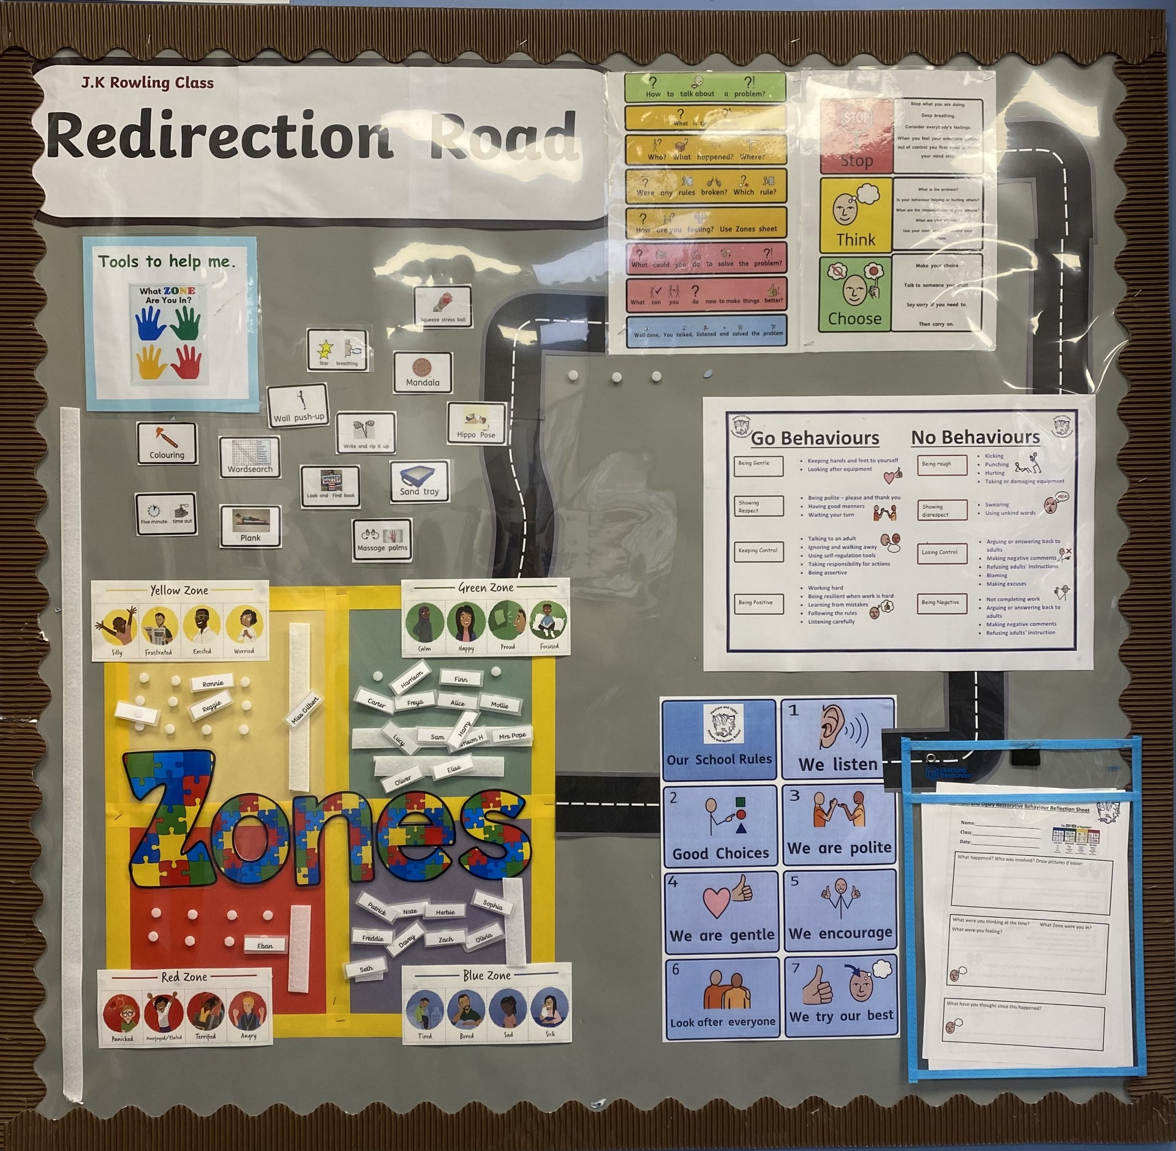
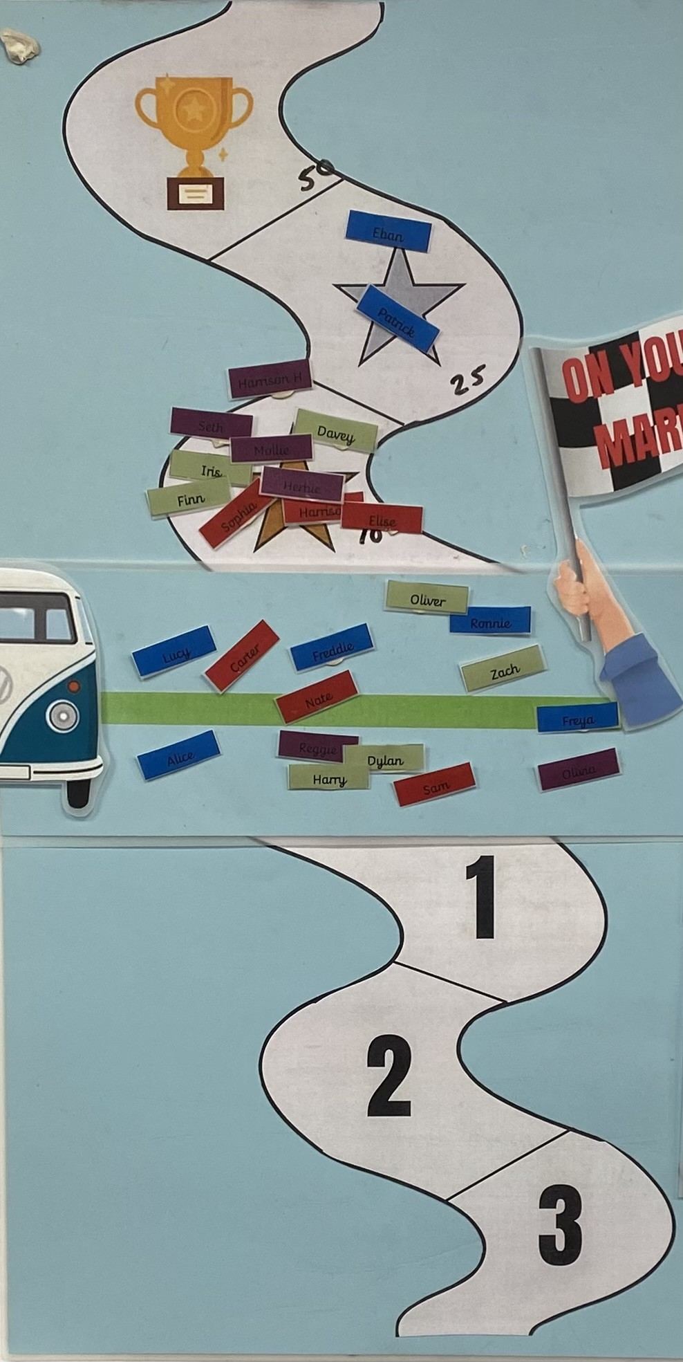

Other strategies we use include:
- Tactical ignoring (e.g. using non-verbal signals, celebrate others’ good behaviour as a role model).
- Positive verbal reminder (e.g. using statements that assume compliance, ‘Peter, we listen to each other, thank you’ or rhetorical ‘how’ questions).
- Children are encouraged to solve their own minor conflicts (we need to ensure we equip the children with the skills to do this, for example using a ‘magic script’).
- Positive verbal reminder (e.g. using statements that assume compliance, ‘Peter, we listen to each other, thank you’ or rhetorical ‘how’ questions).
- Give a choice (a short statement that highlights the expectations and consequences if the negative behaviour continues).
Our gold award acknowledges and celebrates the individual child’s successes and achievements. This will look different for every child, a unique award for our unique children. As a staff we work hard to make sure all children have the opportunity to be celebrated over the year.

Ways to Record Incidents of Concern
We have a clear process and system in place to record incidents that occur. We use the online, cloud based, system ‘My Concerns’ to record all behaviour incidents. The safeguarding team review all recorded incidents regularly.

9. How we Support Children and Young People with Additional Social, Emotional and Mental Health Needs
At our school, we acknowledge that some children will have, at times, additional needs. We recognise that children and young people may experience a range of social, emotional, mental health needs which present themselves in many ways. These may include children and young people displaying challenging, disruptive or stress related behaviours. These behaviours may also reflect underlying social interaction difficulties, sensory or medical needs or clinically diagnosed needs such as attention deficit disorder, attention deficit hyperactive disorder, foetal alcohol disorder or attachment difficulties.
We will always endeavour to understand behaviour, support emotional wellbeing and make reasonable adjustments to our provision to support progress and engagement using a variety of strategies developed with key adults within the child’s life (staff, family, professionals) in order to best meet their needs. In Essex, this is done in the context of One Planning. We also recognise the needs of children and young people with Special Educational Needs and Disabilities (SEND) and follow the policies and procedures associated with supporting these CYP, including but not limited to, the SEND code of practice, Equal Opportunities and Disability Act.
We understand that the behaviour(s) most likely comes from a place of stress which may come from anxiety, fear or as a result of a barrier to learning. We have a duty to strive to help children and young people to return to a place of regulation, within their ‘Window of Tolerance’, as only then will the child be in a place to learn, connect and thrive.
Whilst we will strive to adapt our approach to each individual child we also work to prepare them for society. Teaching our children to consider how their actions have consequences and preparing them for the wider world.
Ways to Support Understanding
At our school we believe that understanding what the behaviour is communicating to us is the first part for planning a response.
Please refer to links at the end of this document, under the heading Further Guidance.

10. Our principles - the things we will do as adults
- Model compassion and kindness, provide hope and support connection and belonging
- Understand that any event in a child’s life can impact on how they think, feel and act
- Use of logical (natural) consequences rather than just simply punishments or sanctions
- Provide routines, set limits and have boundaries
- Regulate our own emotions
- Prioritise relationships to ensure all children feel safe and secure

11. Responsibilities
All staff
- Are responsible for supporting the safety and other needs of children across the school. Where a child is seen to be having difficulties, they should be treated with respect and understanding.
- Always endeavour to have private discussions with child in order to help support any issues that are arising.
- Use the key principles outlined in this policy to support the needs of all our children
- Take responsibility for their own personal safety and wellbeing.
- Contribute actively to risk assessment, and be familiar with policies, guidelines, control measures, instructions and reporting procedures.
- Participate positively in appropriate training.
- Follow the principle of ‘connection before correction’.

Head Teacher
- Leads on all aspects of this policy.
- Is the only person authorised to exclude/suspend a child (deputised to the Assistant Headteacher in their absence).
- Ensures that risk assessments are carried out when required and that appropriate measures are implemented.
- Ensures that all staff receive regular purposeful training to support relationships and minimise risk.
- Ensures that all staff are provided with clear instructions for reporting incidents of harm and that all such reports are thoroughly investigated and responded to.
- Offers and provides appropriate support to staff following a stressful incident.

Other Senior Leaders
- Lead on all aspects of this policy.
- Ensure the policy is implemented effectively.
- Ensure all staff are appropriately trained.
- Oversee the specific needs of all children across the school.
- Provide support to staff, pupils and parents as necessary.
- Link with outside agencies to access additional services.
- Ensure that all tracking and reporting of incidents and additional needs are up to date.

Classroom Staff
- Plan the teaching and learning for all children.
- Include parents/carers in personalised planning for their child.
- Communicate regularly with parents/carers about their child’s needs.
- Provide specific support for children and young people experiencing any difficulties, whether this is an ongoing need or a short term difficult a child may be having.

Family
- Inform the school of any concerns about changes in their child’s behaviour, emotional wellbeing or mental health.
- Have open conversations with the school.
- Engage with support offered by the school and other agencies to further support their child’s needs.

Governors
- Ensure that appropriate policies are in place, that they are regularly reviewed, and their effectiveness monitored.
- Consider families’ representations about an exclusion.
- Undertake their statutory role around exclusion.
- Ensure that all staff receive purposeful training in order that they can undertake their role.

12. Harm from dysregulated behaviour
Our school always prioritises the safety and welfare of all staff and child, recognising that everyone is entitled to a safe and supportive environment. Any incident (verbal or physical) which compromises safety can be perceived as harmful. Our staff understand through training that this behaviour is not necessarily deliberate, rather it is often due to a stress response.
Supporting those who have been harmed
Our staff and children and young people receive the individual support they need in response to any incident where the behaviour has compromised the wellbeing of someone else, causing harm. Occasionally there may be times, despite all reasonably practicable measures being taken, when prevention is unsuccessful, and someone is harmed. At these times our school ensures that this person (adult or child) is fully supported.
We always consider the following:
- are they physically safe and protected?
- do they need immediate first aid & medical treatment?
- is there a need for immediate police involvement?
- ensure they have the opportunity to talk about the incident either with a trusted person or other independent service.
- give reassurance to reduce feelings of guilt and/or anxiety.
Our school recognises that some people are more at risk than others in their work, and where this is the case, we ensure there is appropriate support available.

13. Risk Assessment Process
In our school we use a risk assessment process as the starting point for preventing harm for identified vulnerable child. It identifies what is likely to cause stress to them, using all the information known about the child. Once all this information is to hand, a strategy for supporting a situation appropriately and keeping everyone safe can be developed.

14. Physical intervention (control and restraint) - the use of reasonable force
At our school we make sure we are aware of our duties of care and follow the law. The law states that it is permissible to use reasonable force to prevent pupils committing an offence, injuring themselves or others, or damaging property, and to maintain good order and discipline in the classroom.
The use of physical intervention techniques is only one aspect of co-regulation and is usually the last resort when it is deemed absolutely necessary. It may resolve a short-term situation, but the long-term aim must be to help the child or young person to be able to self-regulate during times of stress.
If such actions are necessary, the actions that we take aim to use the minimum amount of force necessary for the minimum amount of time necessary. Where physical intervention is needed, this is recorded and reported immediately to the headteacher.

Our school follows this Essex Guidance ‘Understanding and Supporting Behaviour - Safe Practice for Schools and Educational Settings (Including the use of restrictive / non restrictive physical intervention)’. It can be found here:
Social, Emotional and Mental Health Portal for Schools, Colleges and Settings - Essex Guidance and Let's Talk Resources
Within this guidance, it is regarded as best practice to record every incident where the use of restraint has been deemed absolutely necessary and to follow the other recommendations set out in this document. This includes reporting to Essex County Council via MySafety.
Where it has been deemed necessary to use a restrictive physical intervention, the detail of this should be accurately recorded and the incident communicated to parents. Parents should be informed of the incident initially by phone and it should then be followed up in writing.

15. Screening and searching pupils
At our school we are all aware that there are two sets of legal provisions which enable school staff to confiscate items from pupils:
‘The general power to discipline’ and the ‘Power to search without consent’; from the ‘Behaviour in schools Advice for headteachers and school staff’ (September 2022).
https://assets.publishing.service.gov.uk/media/65ce3721e1bdec001a3221fe/Behaviour_in_schools_-_advice_for_headteachers_and_school_staff_Feb_2024.pdf
From this guidance our staff understand that they may confiscate items that are of high value, deemed inappropriate and are against the school policies or are causing concern. Where a specific policy about the item does not exist, the teacher should use their discretion about whether the item is returned to the child or to their parent/guardian. Items returned to the child should usually be returned no later than the end of that school day. If the item needs collecting by a parent/guardian, the teacher should ensure that the parent/guardian is made aware that an item has been confiscated – either through the child or via email/phone call. Where the item is of high value or deemed inappropriate, contact should be made directly with the parent/guardian.
Staff do have the power to search without consent for “prohibited items” including:
- knives and weapons
- alcohol
- tobacco and cigarette papers
- fireworks
- pornographic images
- illegal drugs
- stolen items
- any article that has been or is likely to be used to commit an offence, cause personal injury or damage to property; and any item banned by the school rules which has been identified in the rules as an item which may be searched for. The legislation DfE sets out what must be done with prohibited items found as a result of a search.

16. FURTHER GUIDANCE
- Keeping Children Safe in Education 2022
- Reducing the Need for Restraint and Restrictive Intervention (DfE, 2019)
- Use of Reasonable Force (DfE, 2013)
- Behaviour in Schools Guidance September 2022
- Exclusion from maintained schools (DfE, 2022)
- Searching, Screening and Confiscation Guidance September 2022
- Positive environments where children can flourish (Ofsted 2018, updated 2021)
- Creating a Culture: how school leaders can optimise behaviour (DfE, 2017)

Strategies we may use to help us to understand behaviour
STAR Analysis - STAR Analysis Coaching Video Check Video –I don’t have sound so can’t
TTP - Trauma Perceptive Practice (TPP) training | Essex Schools Infolink

APPENDIX I – Reflection Road Documents.
Reflection Road documents

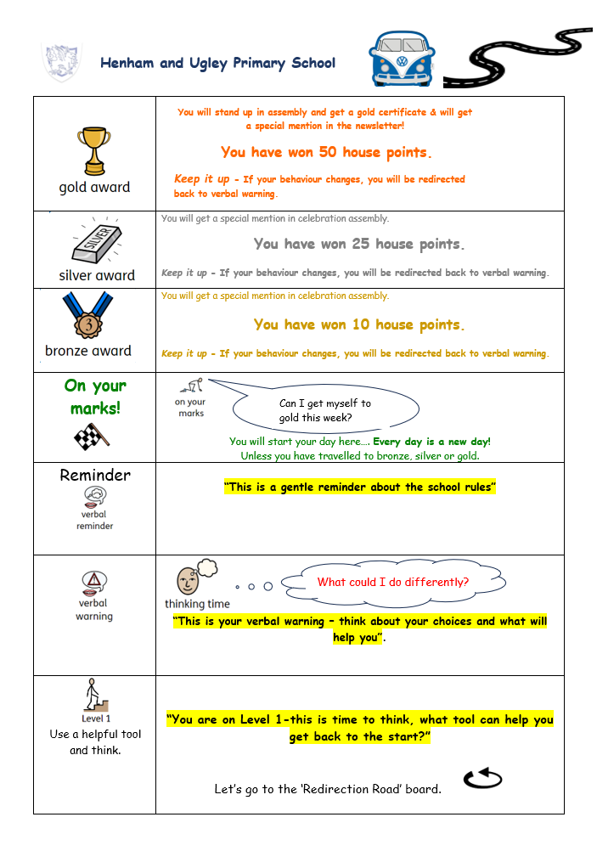

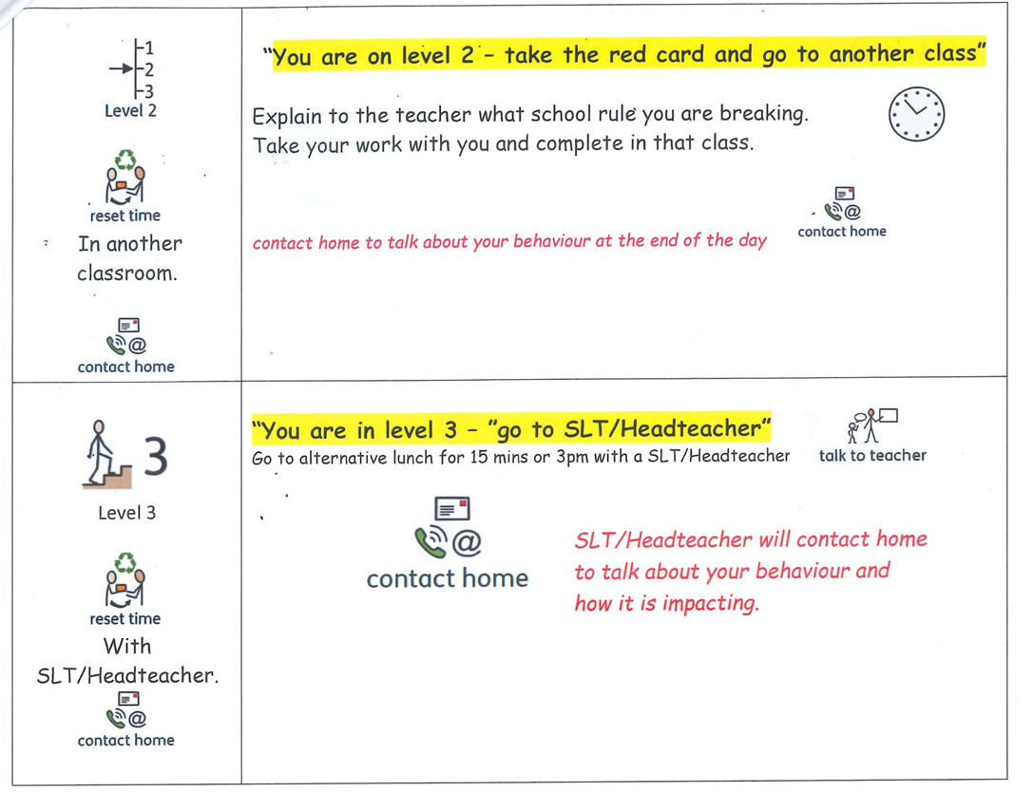

APPENDIX II – Our School Rules
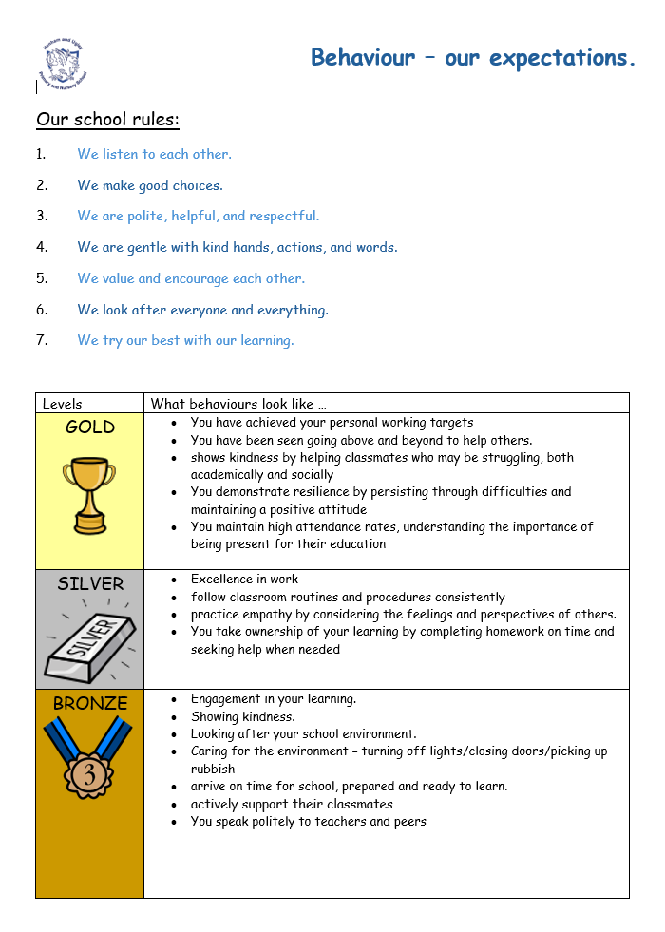

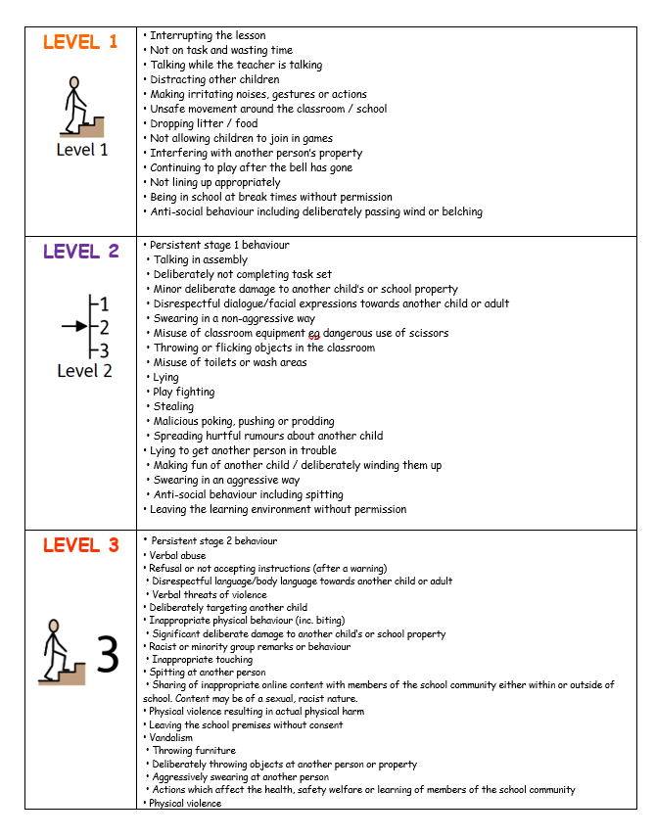

e

